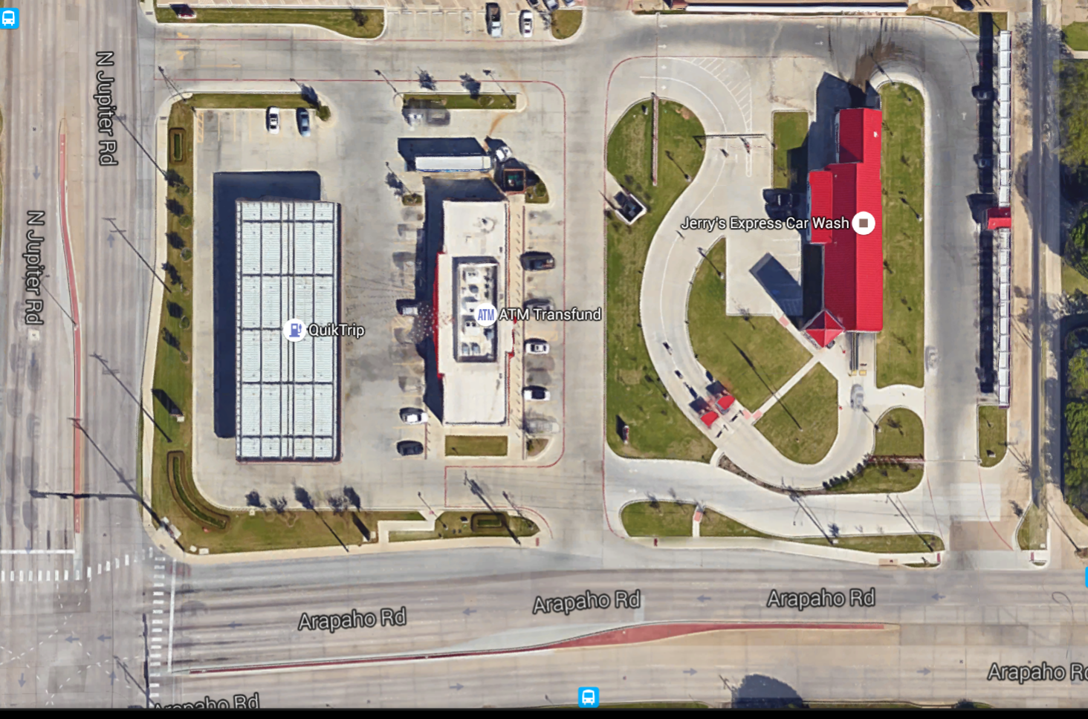
0:Obstacle 1: High way 5: Local 10:Path 15:Slow 20:Rush hour 25:traffic light 30:Accident 50:Under work
5, | 20, | 10, | 10, | 10, | 10, | 10, | 10, | 10, | 10, | 10, | 10, | 10, | 10,
5, | 0, | 0, | 0, | 15, | 0, | 10, | 10, | 0, | 15, | 0, | 0, | 0, | 10,
5, | 0, | 15, | 15, | 15, | 0, | 0, | 10, | 0, | 15, | 0, | 0, | 0, | 10,
5, | 0, | 15, | 0, | 15, | 0, | 0, | 10, | 15, | 15, | 0, | 0, | 0, | 10,
5, | 0, | 15, | 0, | 15, | 0, | 0, | 10, | 15, | 0, | 0, | 0, | 0, | 10,
5, | 0, | 15, | 0, | 15, | 0, | 0, | 10, | 20, | 15, | 0, | 15, | 15, | 10,
5, | 0, | 15, | 15, | 15, | 10, | 10, | 10, | 0, | 15, | 15, | 15, | 0, | 10,
5, | 0, | 0, | 0, | 0, | 0, | 0, | 10, | 0, | 0, | 15, | 15, | 15, | 10,
5, | 50, | 5, | 5, | 5, | 5, | 5, | 5, | 5, | 5, | 5, | 5, | 5, | 5,

